### **Step-by-Step Guide: Connecting the Data to Looker Studio**

1. **Ensure Your Data is Prepared in Google Sheets:**
   * Before connecting to Looker Studio, make sure that the data fetched from Jobber is properly organized and stored in Google Sheets.
   * Review the Google Sheet to ensure that the data is clean, well-structured, and ready for visualization (e.g., headers in the first row, no empty columns).

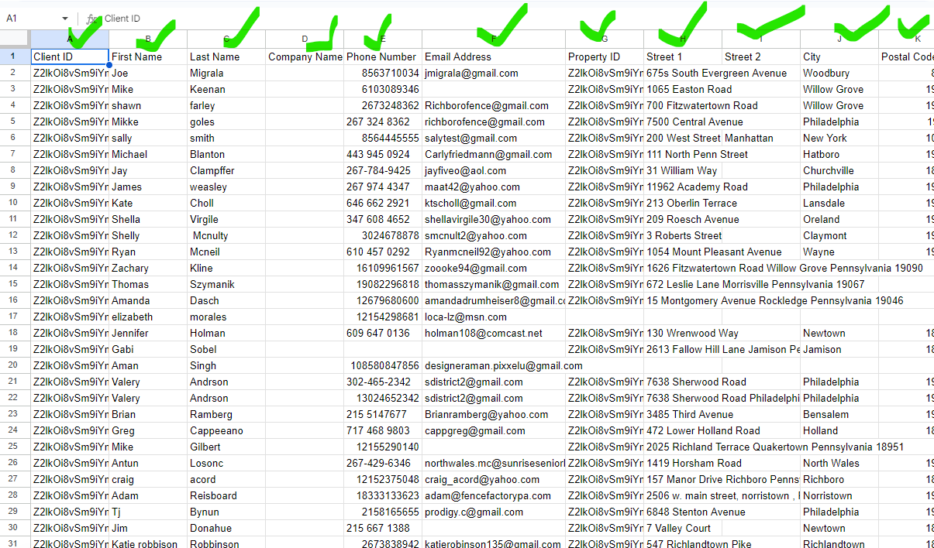

1. **Access Looker Studio:**
   * Open your web browser and navigate to [Looker Studio](https://datastudio.google.com/).
   * Log in with your Google account.

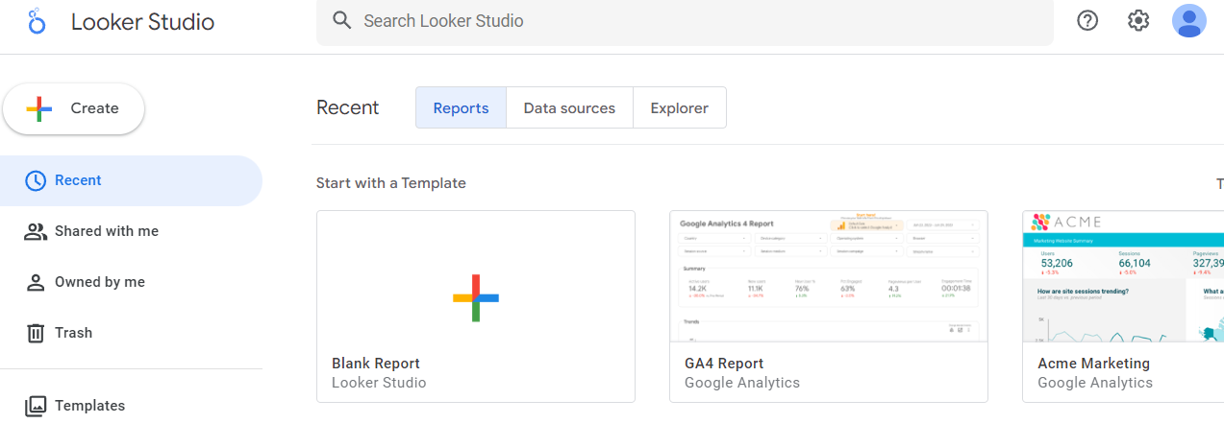

1. **Create a New Report:**
   * Once logged in, click the + Blank Report button to create a new report.
   * You’ll be prompted to choose a data source for your report.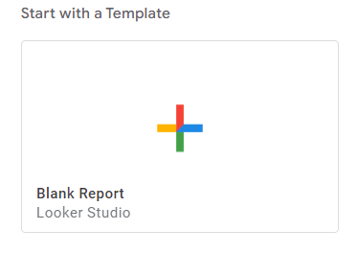
2. **Add Google Sheets as a Data Source:**
   * In the "Add data to report" window, scroll down and select the Google Sheets connector.
   * Grant the necessary permissions if this is your first time connecting Google Sheets to Looker Studio.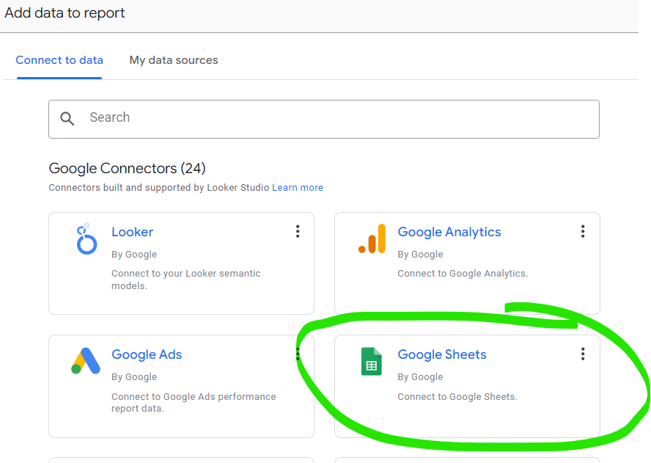
3. **Select the Appropriate Google Sheet:**
   * After selecting the Google Sheets connector, browse your available Google Sheets files.
   * Find and select the Google Sheet where your Jobber data is stored.
   * Choose the specific worksheet (tab) within the Google Sheet that contains the data.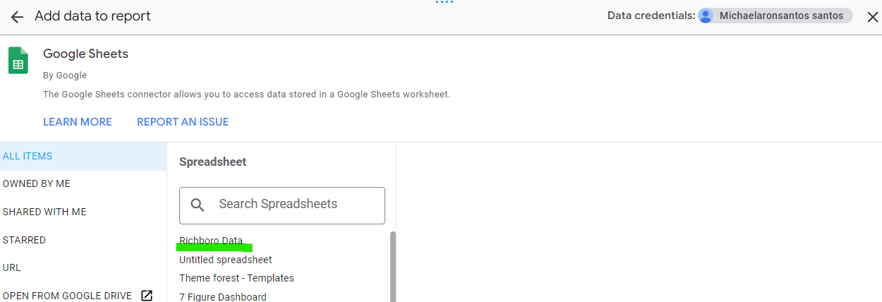
4. **Configure Data Source Settings:**
   * After selecting the worksheet, you’ll see options to configure the data source settings.
   * **Include Hidden and Filtered Cells**: Decide whether you want to include hidden and filtered cells in your data source.
   * **Use First Row as Headers**: Ensure this option is checked so that Looker Studio correctly identifies your column headers.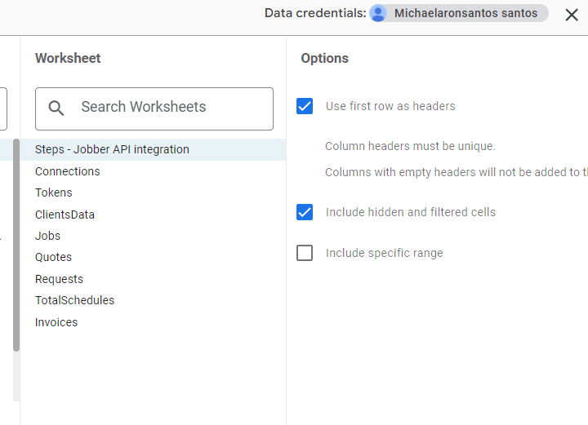
5. **Add the Data Source to the Report:**
   * Click Add in the top right corner to connect the data source to your report.
   * You’ll be prompted to confirm by clicking Add to Report.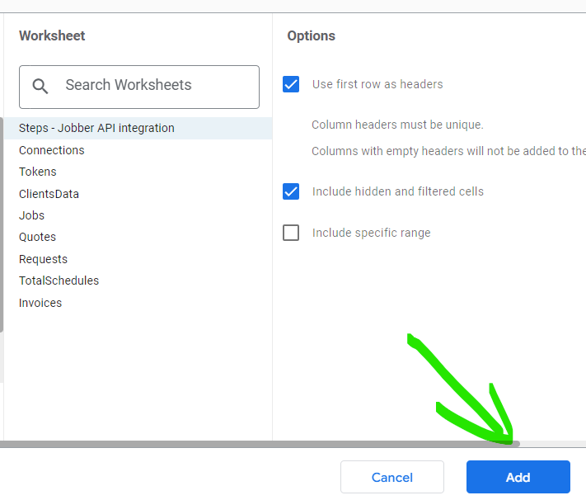
6. **Start Building Your Visualizations:**
   * Once the data source is connected, you can begin creating visualizations:
     + **Add Charts**: Click on the Add a Chart button to insert various types of charts (e.g., bar charts, pie charts, tables, time series).
     + **Customize Fields**: Use the right-hand pane to configure fields, metrics, and dimensions for each chart.
     + **Filter Data**: Apply filters to focus on specific subsets of your data (e.g., by date range, client type).
7. **Customize the Report:**
   * Personalize your report by adjusting the layout, adding text, and modifying styles to suit your needs.
   * You can also add multiple pages to your report if you need to display different types of data or views.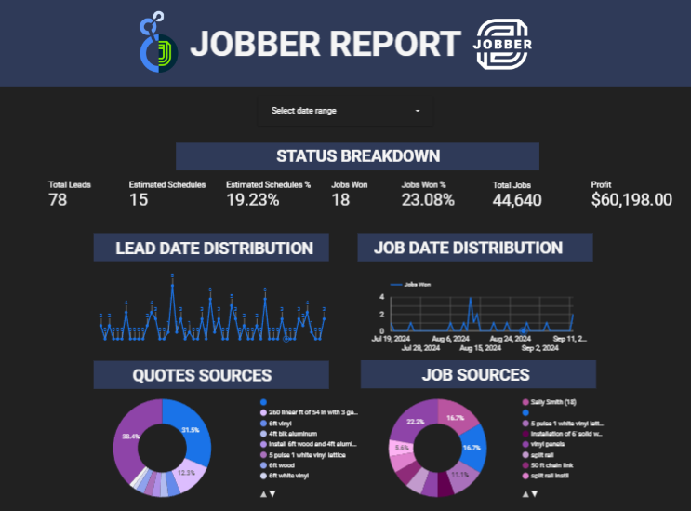
8. **Share and Publish the Report:**
   * When your report is ready, click the Share button to share it with colleagues or clients. You can control access by setting permissions.
   * If you want to publish the report or embed it on a website, use the File > Embed Report option.
9. **Set Up Auto-Refresh (Optional):**
   * To ensure that the data in Looker Studio is always up-to-date, you can set up auto-refresh intervals for the connected data source.
   * This is particularly useful if your Google Sheet is updated regularly by the script fetching data from Jobber